Puru Sai Koushik
2200032991
WEEK-4 . spring-rest-handson

REST - Get country based on country code
Check for your dependencies
You can see you output in the post an or the browser
use your localhost
Here:-8080
http://localhost:8080/countries/in
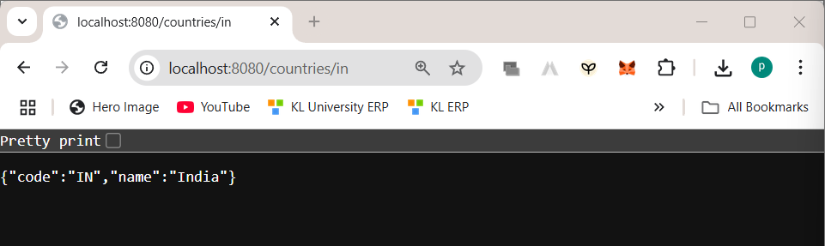
Add the required files
Controller: com.cognizant.spring-learn.controller.CountryController
package com.cognizant.spring_learn.controller;

import com.cognizant.spring_learn.model.Country;
import org.springframework.web.bind.annotation.GetMapping;
import org.springframework.web.bind.annotation.RestController;

@RestController
public class CountryController {

@GetMapping("/countries/in")
public Country getCountryIndia() {
return new Country("IN", "India");
}
}

Method Annotation: @GetMapping("/countries/{code}")
Method Name: getCountry(String code)
package com.cognizant.spring_learn.model;

import javax.xml.bind.annotation.XmlElement;
import javax.xml.bind.annotation.XmlRootElement;
import java.util.List;

@XmlRootElement(name = "countries")
public class Countries {
private List<Country> countryList;

@XmlElement(name = "country")
public List<Country> getCountryList() { return countryList; }
public void setCountryList(List<Country> countryList) { this.countryList = countryList; }
}
Method Implemetation: Invoke countryService.getCountry(code)
Service Method: com.cognizant.spring-

learn.service.CountryService.getCountry(String code)
package com.cognizant.spring_learn.service;

import com.cognizant.spring_learn.model.Country;
import org.springframework.stereotype.Service;

import javax.xml.parsers.DocumentBuilderFactory;
import org.w3c.dom.*;
import java.io.InputStream;
import java.util.ArrayList;
import java.util.List;

@Service
public class CountryService {

public Country getCountry(String code) {
List<Country> countries = loadCountriesFromXML();
return countries.stream()
.filter(c -> c.getCode().equalsIgnoreCase(code))
.findFirst()
.orElse(null);
}

private List<Country> loadCountriesFromXML() {
List<Country> countries = new ArrayList<>();
try {
InputStream inputStream = getClass().getResourceAsStream("/country.xml");
Document doc = DocumentBuilderFactory.newInstance().newDocumentBuilder().parse(inputStream);
NodeList nodes = doc.getElementsByTagName("country");

for (int i = 0; i < nodes.getLength(); i++) {
Element element = (Element) nodes.item(i);
Country country = new Country();
country.setCode(element.getElementsByTagName("code").item(0).getTextContent());
country.setName(element.getElementsByTagName("name").item(0).getTextContent());
countries.add(country);
}
} catch (Exception e) {
e.printStackTrace();
}
return countries;
}
}

